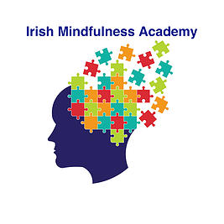 Reflective Journalling

Personal reflection will help you deepen your awareness and therefore your Mindfulness experience. The writing of your experiences will enable you to create a record of the connections and meanings you are making as you engage in learning experiences. The actual writing of the journal will consolidate the reflection process for you.

There is no right or wrong way to journal. Ultimately, your writing should reflect your own experience and observations.

Remember that reflection is also a mechanism by which you can show what you have learned and how you have learned, this is beneficial not only for yourself but is essential for when you later begin to teach Mindfulness, as the early stages of your Mindfulness practice may well be forgotten, unless documented.

